Tausand

Tempico Software 1.1.0

Software for Tempico TP1004

User’s manual

Rev 1.0

January 6th, 2025

[www.tausand.com](http://www.tausand.com)

Contents

1 Definitions 4

1.1 Sampling time 4

1.2 Edge type 4

1.3 Lifetime measurements 4

1.3.1 Fluorescence Lifetime measurements 4

2 Description 5

3 Specifications 5

4 Installation 5

4.1 Windows 5

4.2 Ubuntu 7

4.3 Mac 7

5 Software operation 8

5.1 System configuration 8

5.1.1 Windows 8

5.1.2 Ubuntu 8

5.1.3 Mac 8

5.2 Open the software and select a Tempico device 8

5.3 Channel settings 11

5.4 General settings 13

5.5 Start-Stop Histogram measurements 13

5.5.1 Perform a measurement 13

5.5.2 Save data and plots 17

5.6 Lifetime histograms 19

5.6.1 Settings before a measurement 19

5.6.2 Perform a measurement 20

5.6.3 Fitting 21

5.6.4 Save data and plots 23

6 Technical documentation 25

7 Drivers 25

8 Technical support 25

# Definitions

## Sampling time

The sampling time in an experiment refers to the time window during which data is collected. For example, if we count how many times the laboratory door opens over the course of 2 hours, the sampling time would be 2 hours.

## Edge type

The edge type indicates the type of transition of a digital electrical signal. There are two main types: rise edge and falling edge. If the transition goes from a low level (0) to a high level (1), we call it a rise edge. On the other hand, if we want to register an event when the signal transitions from a high level (1) to a low level (0), we call it a falling edge.

The Tausand Tempico device allows for configuring the edge type for both the start signal and the stop signals. By default, Tausand Tempico is configured for reading rise edges. Below is a time diagram representation with a rise edge configuration for both the start signal (red) and the stop signal (blue).

Now we can see the representation of a *falling edge* configuration for the start signal (red) and the stop signal (blue).

## Lifetime measurements

Lifetime measurements are used to determine how long a molecule, particle, or physical system stays in an excited state before returning to its ground state, or to quantify the duration of a short-lived compound. Most of these measurements are performed by measuring the time difference between two photons.

One of the most widely used techniques for this type of measurement is time-correlated single photon counting or just TCSPC (Hirvonen & Suhling, 2016). This technique relies on the emission of a pulse from a laser, which acts as a trigger to start the measurement. If the laser's frequency is correct, it partially excites the sample. Subsequently, the sample decays and emits a photon back. Some of these photons are detected by an electronic system, which converts them into electrical pulses. These electrical pulses mark the end of the measurement. The time difference between the start pulse and the stop pulse is mapped onto a histogram. Ultimately, the obtained histogram provides information about the temporal distribution of the sample's exciting state.

Tempico software can capture data in techniques that involve the emission and detection of pulses, such as in single photon counting. Several lifetime measurement methods can be applied depending on the type of analysis being performed.

### Fluorescence Lifetime measurements

This technique involves the use of a fluorophore to measure the time it takes to return to the ground state from the excited state. It is primarily used for the analysis of chemical and biological samples. The analysis is conducted by creating an environment with a fluorophore, and any change in the sample causes a modification in the fluorescent environment. In this way, temporal differences associated with interactions or changes in the sample can be obtained (Berezin & Achilefu, 2010)..

# Description

Tempico Software is designed to facilitate the use of the Tausand Tempico TP1004 devices. It is a graphical interface that allows performing time histogram measurements and *lifetime* measurements. From the software, it is possible to configure the device, as well as save the measurement data and generated graphs in various text and image formats, respectively. Additionally, Tempico Software provides extra functions, such as creating custom adjustments for certain graphs, and allowing monitoring the device to ensure the measurement is being performed correctly.

# Specifications

Tempico software is designed to run on devices with low requirements, allowing most laboratories to use it. The minimum requirements for Tempico Software to function are as follows:

* **OS**: Windows 7 Home Premium, Windows 7 Professional, Windows 7 Ultimate, Ubuntu 20.04, Ubuntu 20.10.
* **CPU**: Intel Pentium Dual-Core E5200
* **RAM**: 1 GB
* **Storage**: 500 MB available

For measurements with large data sets or long durations (greater than 6 hours), the performance of Tempico Software may decrease. However, on higher-performance devices, this issue is mitigated.

# Installation

## Windows

The first step is to download the software from the Tausand website: <https://www.tausand.com/downloads/>. From this page, an executable file will be downloaded, which should be run to complete the installation by following the steps provided.

When opening the installer, it will request permission to run, to which we should respond affirmatively. After that, a window will appear asking us to select the installation path. We can choose the desired path; by default, the software will be installed in the Program Files folder.

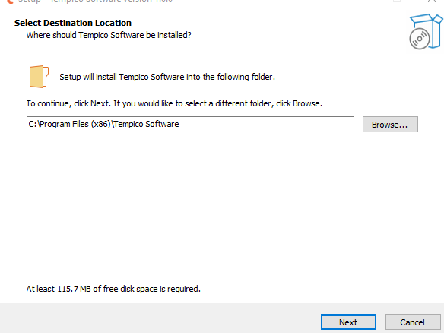

Next, we will be asked if we want to create a shortcut on the desktop. To do so, we should check the corresponding box.

After completing these two steps, a tab will open showing us the installation path, allowing us to verify it before proceeding with the installation.

Once the installation process is complete, we can click "Finish". It is important to check whether we want the program to run immediately, by checking or unchecking the corresponding box.

## Ubuntu

***This feature will soon be available in Ubuntu***

## Mac

***This section will soon be available in Mac***

# Software operation

The software is used in the same way across all operating systems; however, the preparations for running the software may differ depending on the operating system.

## System configuration

To ensure the proper functioning of Tempico Software, it is necessary to perform certain validations on the operating system.

### Windows

You should ensure that the Tempico device is recognized by the COM ports. To do this, follow these steps: If, when connecting and turning on the device for the first time, a window appears indicating that the Tempico device is being configured, it means that Windows has recognized it correctly. If this does not happen, you can access the Device Manager without having the device connected and navigate it to the COM and LPT ports section. Then, connect and turn on the device. The port table should be updated; if it does not, close and reopen the window. When doing so, a new COM device should appear, indicating that the Tempico has been correctly detected.

### Ubuntu

In this case, it is also necessary to verify that the ports are correctly detecting the device. To do this, we will use the following command:

ls /dev/tty*

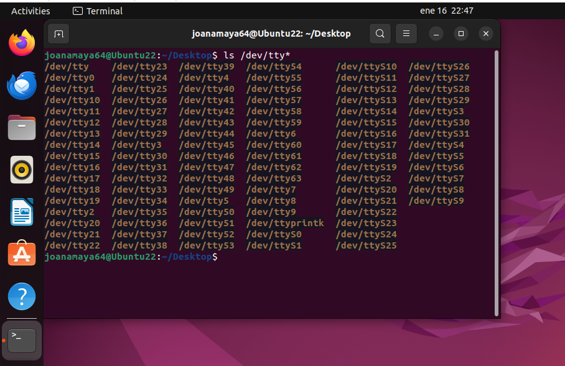

which lists the devices connected to the serial ports. First, we will run this command without the Tempico device connected and then run it again with the device connected. We will observe which new device has been detected.

If an error occurs indicating that the serial port could not be opened, it is possible that the user does not belong to the dialout group. To resolve this, we will execute the following command:

sudo adduser "username" dialout

This will allow the specified user to access the system's serial ports.

### Mac

To verify that the device is correctly connected to Mac, we should, with the Tempico turned off, execute the following command:

ls /dev/tty.*

This will provide a list of connected devices. Then, we run the command again with the Tempico turned on and observe which new port appears in the list.

If the device is not detected, the software will not recognize the connection, making it impossible to use the software. In this case, please contact Tausand support at: [support@tausand.com](mailto:support@tausand.com).

## Opening the software

When opening the software, an image with the program's logo is displayed, followed by a window that allows you to select the port to which you want to connect the device.

If the software is opened and the device is not turned on, the window will not recognize the connection. Therefore, it is necessary to click the "Refresh" button to update the list of ports with a Tempico device.

Once connected, the software will open with all options enabled for use. The software opens by default in the histogram window.

If, in the select port dialog, the "Cancel" button is selected or the dialog box is closed, the options to select a channel or start a measurement will not be available.

If this happens, we can click the "Connect" button again to search for currently available devices.

It is also possible to disconnect the device if we want to use another Tempico. To do so, click the "Disconnect" button. If an error occurs while connecting to the device, the following error window will be displayed:

If this happens, it should be verified that no other program has established communication with the Tempico, and ensure that the USB connection, whether the cable or the physical port, is in good condition. If no issues are found after verifying this, support should be contacted to find a solution to the problem.

If you need to connect two devices at the same time, the user can open two instances of the software and use them simultaneously, as long as each instance does not connect to the same serial port.

## Channel settings

Once the connection with the device is established, it is possible to access the settings for each channel. To do so, go to the tab at the top, select "Settings," and then choose "Channel Settings," where you can view the current settings of the device:

For each channel, you can modify the number of average cycles, the mode that defines the time range for measurements, the number of stops, the edge type, and the stop mask. All these options provide a dropdown menu with the options allowed by the device (refer to the Tausand Tempico manual for more information), except for the stop mask.

For the "Stop Mask," you can enter an integer number between 0 and 4000 µs.



Once the desired values have been changed, click the "Apply Changes" button to transmit the changes to the device. To verify the changes, you can return to the tab and check that the values are the same as those previously set.

## General settings

The software features another window that displays the options affecting all channels of the device, including the start channel. To access it, go to the top, select "Settings”, and then click on "General Settings":

From there, it is possible to set the "Threshold Voltage" and the "Number of Runs" for the measurements. The "Threshold Voltage" value allows a range between 0.90 and 1.60, with increments of 0.01, while the "Number of Runs" allows integer values up to a value of 1000 (for more information on these settings, refer to the device manual). Once the changes have been made, click on "Save Changes," and to confirm, return to the tab and check that the values are the same as those set.

## Start-Stop histogram measurements

"Start-stop" measurements are those that capture data from the basic functionality of the Tempico device. When a start pulse is received and, subsequently, a stop pulse arrives, the temporal difference between the two pulses is obtained. This data is plotted on a frequency histogram.

### Perform a measurement

To begin a sequence of "start-stop" measurements, the channels to be sampled must be selected. To do so, check the corresponding checkboxes located on the left side of the window.

Afterward, click on "Begin Measurement" (). Depending on the number of channels selected, the corresponding graphs will be created on the right side of the window. Once the measurement begins, a histogram will be obtained for each channel.

It is possible to interact with the graphs generated for each channel, either by dragging the range or adjusting the zoom with the mouse wheel. The histogram is generated according to the zoom level of the plot. Therefore, by zooming in and examining the range in more detail, more precise points will be obtained, indicating where each data point falls.

Conversely, if we increase the temporal axis range, the number of bars will decrease.

Right-clicking on the graph enables additional options for interacting with it, such as manual zoom on each axis, changing the selection mode with the mouse, or exporting the image. Since these options come from the library used to generate the graph, it is not recommended to interact with the graph through these functions. However, the user is free to use them if desired.

The status bar indicates whether the measurement is being carried out correctly. If any channel is not receiving data, the status bar will display a message to indicate this.

If the start channel is not receiving data, the following message will be displayed:

A possible solution to this issue is configuring the threshold voltage. It is recommended to set it to 1.6 V and check if the measurement is performed correctly. If the error persists, try different values for this parameter. If the issue continues and it is determined that it is not a fault in the setup or the input signal, Tausand support should be contacted.

Start-stop histograms are designed to take measurements indefinitely. Once the experiment is considered complete, click the "End Measurement" button ( ) to stop data collection. If you wish to clear the data during the experiment, there's no need to stop the measurement. At the bottom of the left menu, there are "Clear" buttons to erase both the data and current graphs. Four buttons are available to clear data for each channel independently ( , , , ).

### Save data and plots

If the users wish to save the graphed data, they should click the save button ( ), which will open a menu allowing them to select the format in which to save the files.

After selecting the desired format, click the accept button ( ), which will display a dialog box indicating that the file has been saved successfully.

Files are saved in all operating systems in the "TempicoSoftwareData" folder within "Documents." By default, this folder is automatically created when the program is opened for the first time.

The data is saved in the same format. First, it includes the configuration applied when the data was collected, followed by the raw histogram information. This allows the users, if desired, to later manipulate the data according to their needs.

If the users wish to save the graphs generated by the software during the measurement, they must click on the "Save Plots" button ( ). A window will then open, allowing them to select the image format.

After selecting the format, click the "Accept" button ( ). As with the previous case, a dialog box will appear indicating that the image has been successfully saved. The image will be saved in the same location as the text files, across all operating systems.

The saved image is the one displayed in the software at the moment of clicking "Accept." Therefore, the zoom applied to the graph will also be reflected when saving the image. If multiple channels are selected for measurement, the 4 images will be saved separately.

## Lifetime histograms

To record lifetime measurements based on the time difference between input pulses and emitted excitation pulses, Tempico Software provides multiple tools to fulfill this functionality.

### Settings before a measurement

Unlike the measurement of start and stop histograms, the preliminary setup for a lifetime measurement is a bit more elaborate. First, we must select the start channel and the stop channel for our measurements.

If a channel other than the start channel is selected to initiate the measurement, a periodic electrical signal must be added to the start channel, as Tempico cannot measure signals on stop channels without a registered start event. This configuration risks losing data that arrives before the periodic signal is emitted. The pulse period must be short enough to minimize data loss. Tempico does not register stops occurring within less than 12 ns, making this setup useful for mitigating such effects.

For this configuration, the order of arrival times does not matter. For example, if we have two stops: stop1 and stop2, it is not necessary for stop1 to always arrive before stop2, so negative time differences can be recorded.

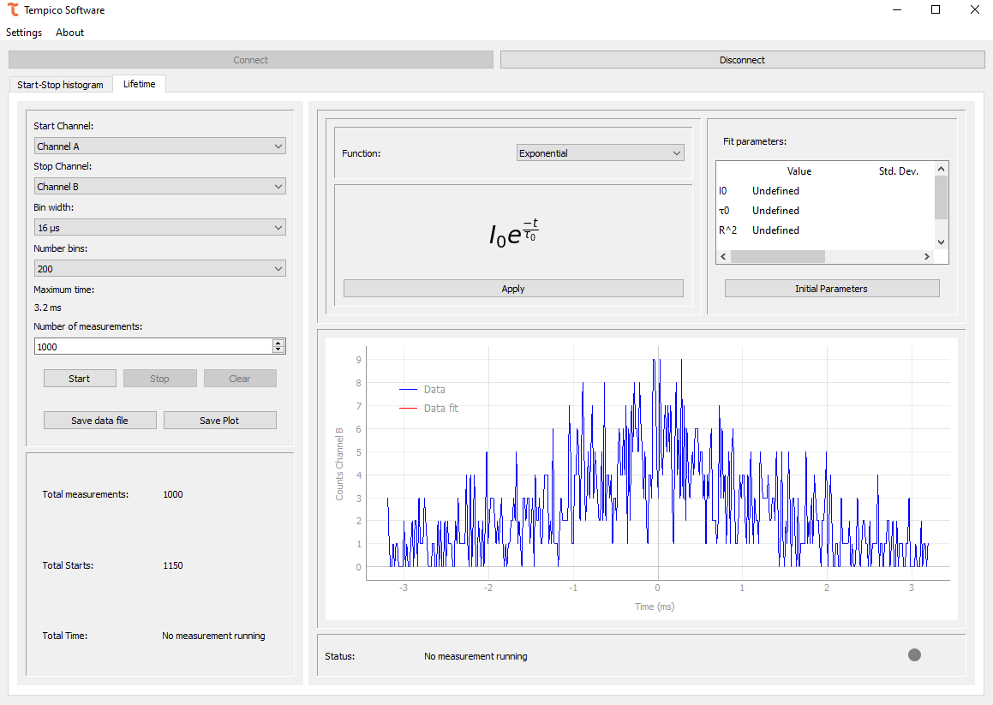

After selecting the channel, the bin width must be chosen, representing the histogram's bar width. For example, with a bin width of 12 ns, if there are two measurements at 1 ns and 5 ns, both will contribute to the same histogram bar's frequency. The number of bins prevents histogram saturation and usually limits the time axis range. For instance, selecting a bin width of 480 ps and 50 bins results in a 24 ns range. Unlike start-stop histograms, lifetime measurements are designed with a limit, allowing the number of measurements to be specified. A measurement is counted when both start and stop channels record a value.

It's important to clarify that the configurations for the number of runs, number of stops, stop mask, and mode have no effect on this measurement. By default, the program sets the number of runs to 100, the number of stops to 1, the stop mask to 0, and the mode according to the maximum time parameter. If the maximum time exceeds 500 ns, the measurement operates in mode 2; otherwise, it operates in mode 1.

### Perform a measurement

Once the desired configuration is selected, click the start button ( ) to begin the measurement. Like start-stop histograms, the program displays a status bar indicating the measurement's progress. If any channel is not recording, it will be shown. In this case, the percentage of the measurement is also displayed, as the number of desired measurements can be specified.

The program also provides additional information about the measurement status, including the total number of starts, the total number of complete measurements (i.e., start and stop), and the total elapsed time in HH:MM:SS format.

### Fitting

To obtain more information about a measurement, the user can fit a model to the graph. After performing the fit, the table in the top-right corner will display more detailed information about the parameters of the fitted equation. It will show their values, standard deviations, and respective units.

In some cases, reliable values may not be estimated, and the adjustment will indicate "nan" for those parameters. The quality of the fitness depends on the initial parameters set before the estimation. Therefore, users are free to modify these parameters. They can also revert to the default values provided by the software.

The software offers various types of adjustments:

#### Exponential

For fluorescence decay processes and certain radioactive processes, it is common to encounter exponential distribution (Jameson, 2014). This distribution involves two parameters: by default, the initial value of ​ is set to the maximum found on the graph, and the initial value of ​ corresponds to the average of the measured times.

#### Shifted Exponential

In some cases, an exponential distribution may exhibit a shift due to noise or inherent system characteristics. For these situations, an option for an exponential distribution with a shift is provided, allowing the user to correct the shift and obtain a pure exponential distribution. The initial parameters ​ and ​ are the same as those used by default in the exponential distribution. The additional parameters and are set to 0 by default.

#### Kohlrausch

In the case of fluorescence lifetime measurements, interactions may occur both in the environment and with the fluorescent material, which can be interpreted as noise in the final measurement (Lee et al., 2001). To obtain a profile that represents the dynamics of fluorescence, a Kohlrausch fit can be used. The default initial value for the parameter is 1.

#### Double Exponential

In some cases, the data may have more than one component, and the user may wish to separate the parameters of each. For these cases, a double exponential fit can be used. The default values are the same as those used in the exponential distribution; the default value for is 1, and the value for is the same as .

### Save data and plots

Like the histogram functionality, the user has the option to save both the data and the image. If the user clicks the **Save Data File** button ( ), a window will appear to select the desired format for saving the data. The user can choose between txt, csv, or dat formats.

If the user clicks the **Accept** button ( ), a window will appear confirming that the file has been successfully saved and displaying the path where it was stored.

If the users click **Save Plot** ( ), they can choose from three formats: PNG, TIFF, and JPG. Upon clicking the **Accept** button, a window will confirm that the file has been successfully saved and display the path where it was stored.

If an adjustment is applied, both the image and the text data will include the equation of the adjustment made, along with the calculated fitting parameters.

# Technical documentation

Tempico Software is open source, allowing access to the software's source code and developer documentation through the GitHub platform. It also provides a guide to the code and the creation of respective installers for each operating system.

<https://github.com/Tausand-dev/TempicoSoftware>

# Drivers

Your computer may automatically download and install from the Internet the required drivers once you connect your Tausand Tempico device to a USB port. If you require to install them manually, they are available at <https://www.tausand.com/downloads>.

# Technical support

For technical support, contact us at [support@tausand.com](mailto:support@tausand.com).

Visit our website to check for the latest documentation and software releases.

[www.tausand.com](http://www.tausand.com)

# Bibliography

* Hirvonen, L. M., & Suhling, K. (2016). Wide-field TCSPC: methods and applications. *Measurement Science and Technology*, *28*(1), 012003.
* Berezin, M. Y., & Achilefu, S. (2010). Fluorescence lifetime measurements and biological imaging. *Chemical reviews*, *110*(5), 2641-2684.
* Lee, K. B., Siegel, J., Webb, S. E. D., Leveque-Fort, S., Cole, M. J., Jones, R., ... & French, P. M. W. (2001). Application of the stretched exponential function to fluorescence lifetime imaging. *Biophysical journal*, *81*(3), 1265-1274.
* Jameson, D. M. (2014). *Introduction to fluorescence*. Taylor & Francis.